Yom Chi Martial Arts & Family Learning Centre  Student Registration & Waiver Forms | 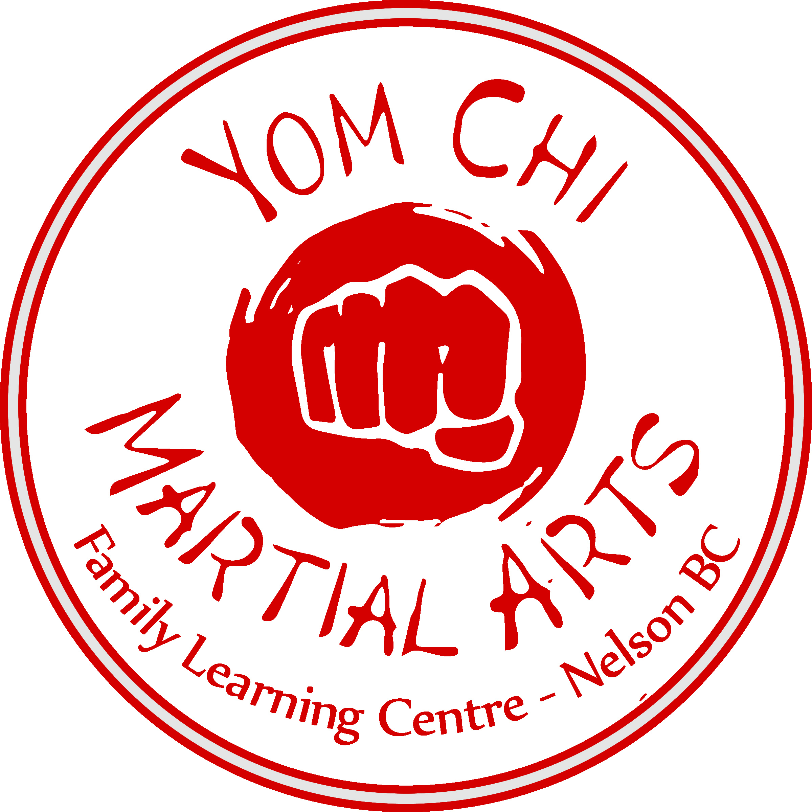

Name: ______________________________________________________________________________
Date of Birth: _______________________________ Male: ________ Female: ________
Address: ____________________________________________________________________________
Phone # home: _________________________________ cell: ________________________________
Email: _______________________________________________________________________________
Medical: (Med-alert, allergies, previous injuries)
____________________________________________________________________________________
____________________________________________________________________________________
____________________________________________________________________________________
____________________________________________________________________________________

Emergency Contact info: ________________________________________________________________
(name) (relationship) (phone number)

How did you hear about us? _____________________________________________________________

Please circle the days of the week you are registering for: Monday Tuesday Wednesday Thursday Friday

Current Rank (if applicable): _____________________________________________________________

Administration Area:
Uniform Size: _____ Enrolment Date: __________________________

Photo and Media Release
As a member of our Martial Arts school, your image and/or name may be used in the following contexts:
- Posted on our webpage, our social media pages and/or advertising and marketing posters/media
- Shared as part of School presentations/demonstrations
In accordance with the Freedom of Information and Protection of Privacy Act, we require consent to use personal information that may be accessible to the public.
(___) Yes, I give consent for the publication of my image and/or name for purposes consistent with the above.
(___) No, I do not permit the publication of my image and/or name for purposes consistent with the above

WAIVER and ASSUMPTION OF RISK

To: Yom Chi Martial Arts & Family Learning Centre, and the directors and officers and agents thereof.
When accepted, this Registration and Membership Application shall form and define the terms of the agreement between Yom Chi Martial Arts & Family Learning Centre (Employees or Agents), and the member whose name is set forth above.
Yom Chi Martial Arts & Family Learning Centre agrees to provide me with instructors and facilities for teaching Tae Kwon Do at the various levels and belt classifications. I understand that all classes, practice sessions and examinations will be supervised by personnel trained in the procedures and traditions of Tae Kwon Do and that official belt recognition and appropriate certificates will only be issued to me upon completion of full belt examination and payment of the examination fee. I also understand that strict observation by the member, of the rules and regulations relating to my training, will eliminate or reduce the possibility of accident or injury, and I hereto agree to observe same, failing which my Membership may be terminated without refund or allowance. I further acknowledge and agree:
(a) that the activities are very dangerous, exposing Members to many risks and hazards, some of which are inherent in the very nature of the sport itself, and others which may result from Gross Negligence or fault on the part of the persons and others involved in preparing and organizing the Tae Kwon Do lessons;
(b) that as a result of the aforesaid risks and hazards, I as a Member may suffer personal injury, even death as a result of participation in the activities;
(c) some of the aforesaid risks and hazards are foreseeable but others are not;
(d) that I nevertheless freely and voluntarily assume all of the aforesaid risks and hazards and that, accordingly, use of the facilities while participating in any of the activities shall be entirely at my own risk;
(e) that I understand that none of the directors, officers, employees or agents of Yom Chi Martial Arts & Family Learning Centre assume any responsibility or liability whatsoever for my safety while I am participating in any of the activities, and I agree to waive any and all liability;
(f) that I carefully read this Waiver and Assumption of Risk, that I fully understand same and I freely and voluntarily execute the same;
(g) that this Waiver and Assumption of Risk is binding upon myself, my heirs, my executors, administrators, personal representatives, and assigns and I hereby expressly release the agents, employees, officers and directors of Yom Chi Martial Arts & Family Learning Centre from any and all liability and waive as against them all recourse, loss of damages, including any consequential damages or loss, claims, causes of action of any kind whatsoever and I voluntarily accept the legal risk, thereby expressly give up any right of action, and the physical risk as rising from all liability whether such liability rises in contact, by any reason of gross negligence or by reason of breach of duty raised by statute, or in any other matter whatsoever.
Any membership fees paid under this agreement are non-refundable and thirty (30) days notice of intention to withdraw is required. In lieu of notice, one month’s fees will be retained.
WARNING: By signing this document you give up your legal rights. This document contains onerous and unusual clauses – read thoroughly and carefully before signing.

Student/Participant Signature X___________________________________________________________________
Parent or Guardian Signature (if minor) X___________________________________________________________
Printed Name of Student/Participant _______________________________________________________________
Address of Participant __________________________________________________________________________
Received by ________________________________ _____________________________ ___________________
Registrar Signature Printed Name Date

