Testing Requirements
Black Dove – School Emblem

$5 fee for this test
If you think you are ready to test, Please see Mr. Bain before or after class for pre-testing.

Testing Date: ________________________________________________
Student name: _______________________________________________
Instructor’s signature: __________________________________________

Student should be able to explain the meanings of the all the parts of the school emblem in a loud, clear voice.

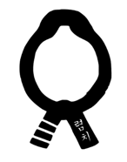

Meaning: Korean for Integrity Meaning: 3 bars to signify Mr Bain’s rank when he started the school and Yom Chi in Korean characters

Meaning: International symbol of gratitude Meaning: hands symbolize Koryo poomsae; a learned martial artist, releasing the dove, a symbol of peace and love to others

Meaning: International symbol of ego Meaning: International symbol for TKD and Karate; symbolizes smashing bad ego, the destroyer of dreams

“Perfect Practice Makes Perfect”

